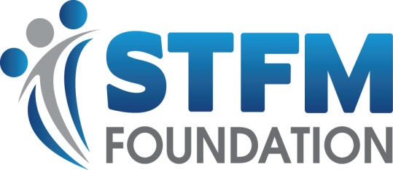
Nomination Form for the 2020 STFM Foundation Board of Trustees
Name: Degree(s):

Institution:

City/State:

Primary role:

Email: Phone:
STFM Foundation Trustee Responsibilities – Four Open Positions, Effective May 2020
Trustees for the STFM Foundation are nominated by the Foundation Board of Trustees and elected by the STFM Board of Directors, who serve as the membership of the Foundation. Trustees serve a 4-year term, beginning and ending at the STFM Annual Spring Conference.
Expectations of a Trustee:
- Attend all meetings of the Foundation Trustees (two in-person meetings a year; one at the STFM Annual Spring Conference, the other in Kansas City in the fall). Expenses for these meetings are paid by the individual, although the fall meeting offers a travel stipend up to $500.
- Raise money for the Foundation and participate in fund-raising activities
- Serve as an ambassador for the Foundation by actively sharing information about its programs and the need for financial support
- Support the Foundation's Annual Giving Campaign at an appropriate level
- Serve on at least one of the Foundation's work groups
- Participate in the assessment of the Foundation mission and programs
- Respond in a timely fashion to all communications to Trustees between meetings

Please share with us a statement of interest listing your relevant experience in these areas (responses in bulleted form preferred; 2 page maximum):
- Length of time in any family medicine faculty position
- Previous Board experience (specify STFM, other non-profit, or other)
- Fund-raising experience
- Other special characteristics, perspectives, experiences that would make you a strong contributor to the STFM Foundation Board of Trustees

For consideration for the 2020 Foundation Board of Trustees, please send your statement of interest and photo to Pat Lodge by December 2, 2019 plodge@stfm.org, 800-274-7928, x5528.

How does the Nominations Committee make its selections for Trustee members?
The STFM Foundation Nominations Committee considers a wide range of characteristics and factors in identifying Board of Trustees candidates, including:
- Commitment to STFM and its mission
- Belief in the Foundation as demonstrated through prior donor support
- Specific perspectives and expertise needed on the Trustees, eg, visionary thinkers, residency directors, young faculty, change agents, etc.
- Unique expertise of the individual, eg, fund-raising expertise, strong connections with foundations
- Ability to represent the organization’s needs over personal (or group’s) interests
- Critical and strategic thinking skills
- History of STFM involvement
- Strong leadership skills
- Effective fiscal management skills
- Contribution to diversity of the Board in the broadest sense - gender, age, degree, ethnicity, role, etc.
- Demonstrated skills at building relationships
- Ability to change with needs of the organization

